**DSA0616-DATA HANDLING AND VISUALIZATION**

**DAY 01 PROGRAM ANSWERS**

**GITHUB FILE**

**Day 1 – Practical Session**

**Course Code: DSA0612**

**Course: Data Handling and Visualization**

**1. Visualize Scatter plot for given dataset.**

|  |  |
| --- | --- |
| Weight (kg) | Height (cm) |
| 60 | 170 |
| 65 | 175 |
| 70 | 168 |
| 72 | 180 |
| 75 | 178 |

**Sample Code:**

**# Load necessary library**

**library(ggplot2**

**# Create a data frame**

**weight_height_data <- data.frame(**

**Weight = c(60, 65, 70, 72, 75),**

**Height = c(170, 175, 168, 180, 178)**

**)**

**# Plot scatter plot**

**ggplot(weight_height_data, aes(x = Weight, y = Height)) +**

**geom_point(color = "blue", size = 3) +**

**labs(title = "Weight vs. Height",**

**x = "Weight (kg)",**

**y = "Height (cm)") +**

**theme_minimal()**

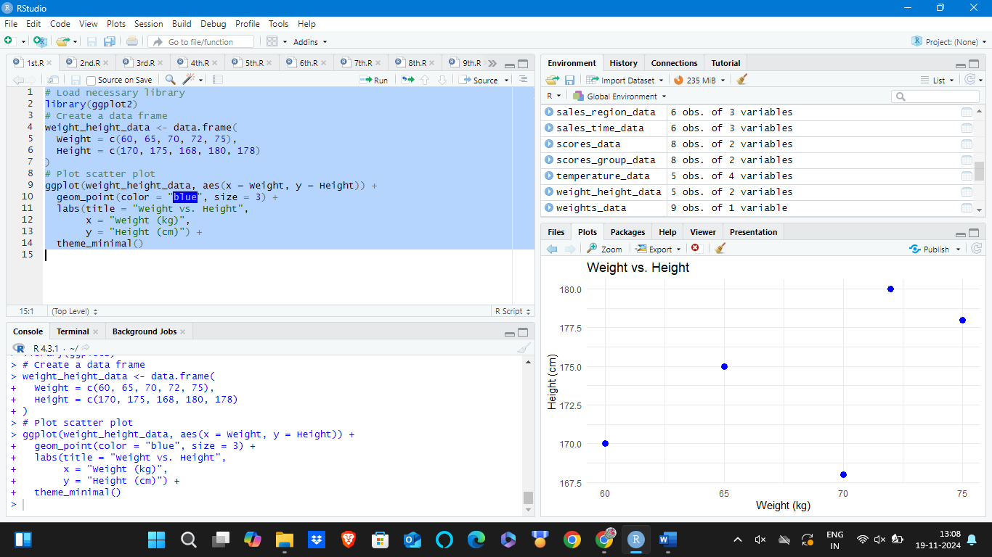

**2. Visualize a Line Plot for the Given Population Data**

|  |  |
| --- | --- |
| **Year** | **Population (millions)** |
| 2010 | 1000 |
| 2011 | 1020 |
| 2012 | 1040 |
| 2013 | 1060 |
| 2014 | 1080 |

**# Create a data frame**

**year_population_data <- data.frame(**

**Year = 2010:2014,**

**Population = c(1000, 1020, 1040, 1060, 1080)**

**)**

**# Plot line plot**

**ggplot(year_population_data, aes(x = Year, y = Population)) +**

**geom_line(color = "green", size = 1) +**

**geom_point(color = "red", size = 3) +**

**labs(title = "Year vs. Population",**

**x = "Year",**

**y = "Population (millions)") +**

**theme_minimal()**

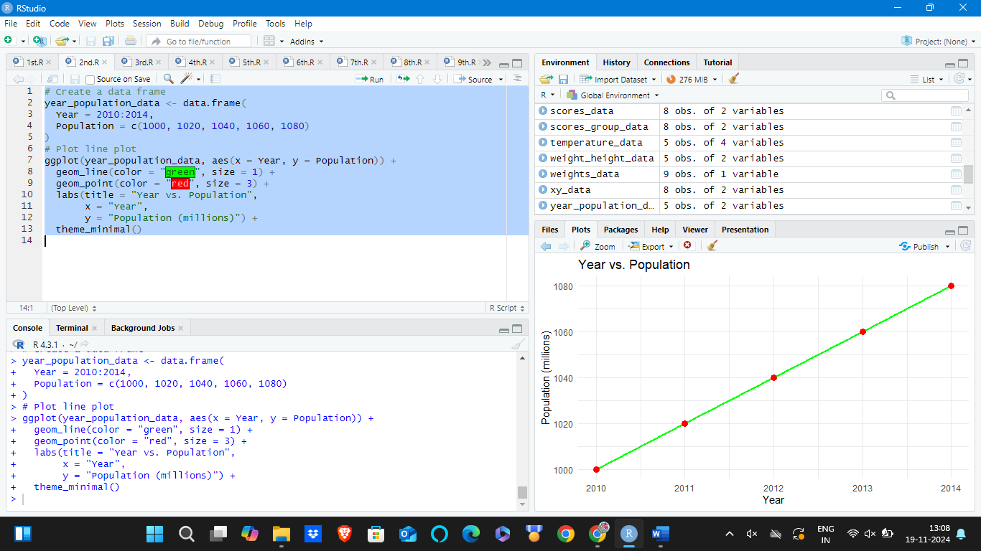

**3. Bar Plot**

**Dataset: Sales by Product**

|  |  |
| --- | --- |
| Product | Sales |
| A | 300 |
| B | 450 |
| C | 500 |
| D | 350 |
| E | 400 |

**# Create a data frame**

**sales_data <- data.frame(**

**Product = c("A", "B", "C", "D", "E"),**

**Sales = c(300, 450, 500, 350, 400)**

**)**

**# Plot bar plot**

**ggplot(sales_data, aes(x = Product, y = Sales, fill = Product)) +**

**geom_bar(stat = "identity") +**

**labs(title = "Sales by Product",**

**x = "Product",**

**y = "Sales") +**

**theme_minimal()**

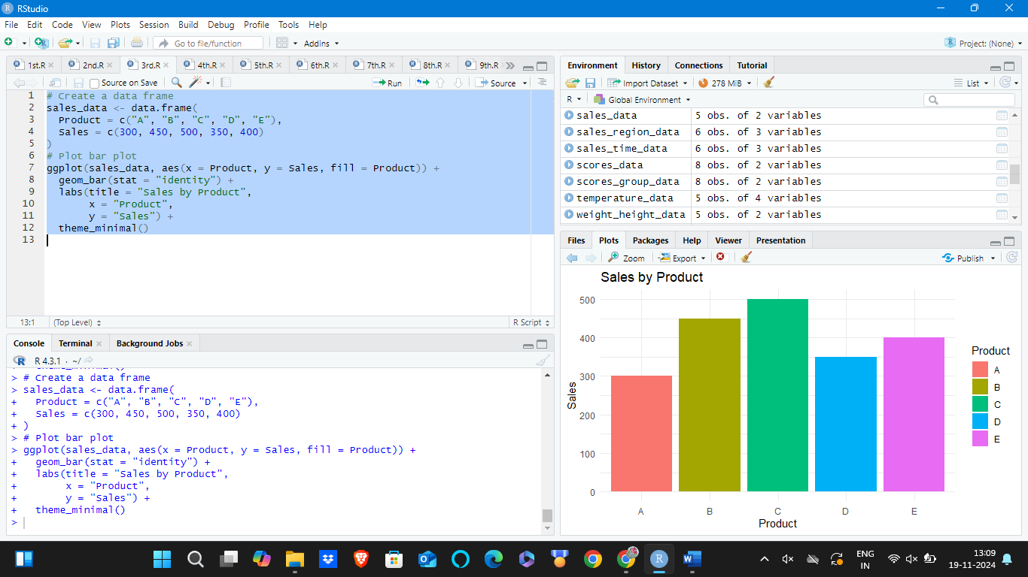

**4. Histogram**

**Dataset: Age Distribution**

|  |  |
| --- | --- |
| | **Age** | | --- | |
| |  | | --- | | 25 | |
| |  | | --- | | 30 | |
| |  | | --- | | 35 | |
| |  | | --- | | 40 | |
| |  | | --- | | 45 | |
| |  | | --- | | 50 | |
| |  | | --- | | 55 | |
| |  | | --- | | 60 | |
| |  | | --- | | 65 | |
| |  | | --- | | 70 | |

**# Create a data frame**

**age_data <- data.frame(**

**Age = c(25, 30, 35, 40, 45, 50, 55, 60, 65, 70)**

**)**

**# Plot histogram**

**ggplot(age_data, aes(x = Age)) +**

**geom_histogram(binwidth = 5, fill = "purple", color = "black", alpha = 0.7) +**

**labs(title = "Age Distribution",**

**x = "Age",**

**y = "Frequency") +**

**theme_minimal()**

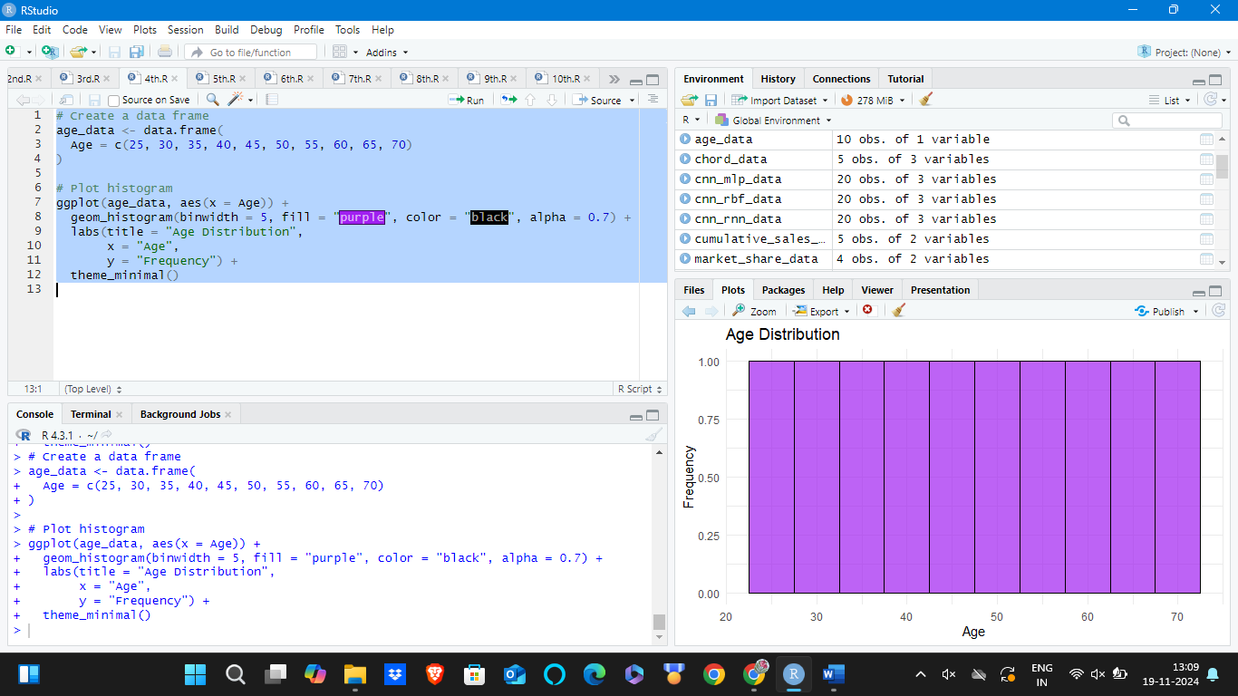

**5. Pie Chart**

**Dataset: Market Share by Company**

|  |  |
| --- | --- |
| Company | Market Share |
| A | 20% |
| B | 30% |
| C | 25% |
| D | 25% |

**# Create a data frame**

**market_share_data <- data.frame(**

**Company = c("A", "B", "C", "D"),**

**Market_Share = c(20, 30, 25, 25)**

**)**

**# Plot pie chart**

**ggplot(market_share_data, aes(x = "", y = Market_Share, fill = Company)) +**

**geom_bar(stat = "identity", width = 1) +**

**coord_polar("y") +**

**labs(title = "Market Share by Company",**

**x = NULL,**

**y = NULL) +**

**theme_void() +**

**theme(legend.position = "right")**

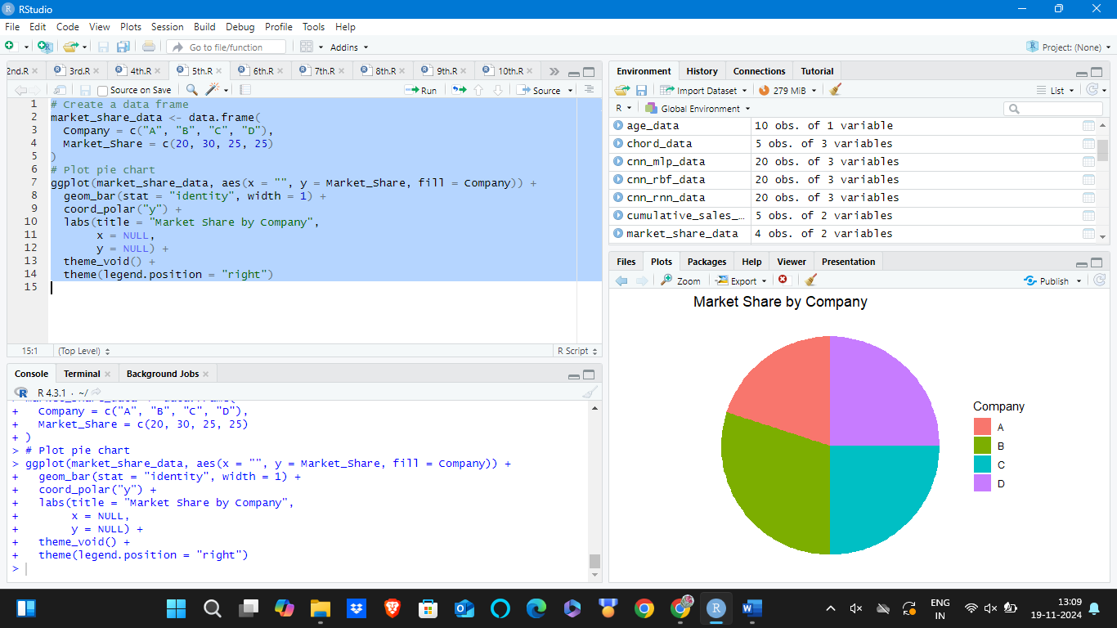

**6. Box Plot**

**Dataset: Exam Scores by Class**

|  |  |
| --- | --- |
| Class | Scores |
| A | 85 |
| A | 90 |
| A | 78 |
| A | 92 |
| B | 88 |
| B | 76 |
| B | 80 |
| B | 84 |

**# Create a data frame**

**scores_data <- data.frame(**

**Class = c("A", "A", "A", "A", "B", "B", "B", "B"),**

**Scores = c(85, 90, 78, 92, 88, 76, 80, 84)**

**)**

**# Plot box plot**

**ggplot(scores_data, aes(x = Class, y = Scores, fill = Class)) +**

**geom_boxplot() +**

**labs(title = "Exam Scores by Class",**

**x = "Class",**

**y = "Scores") +**

**theme_minimal()**

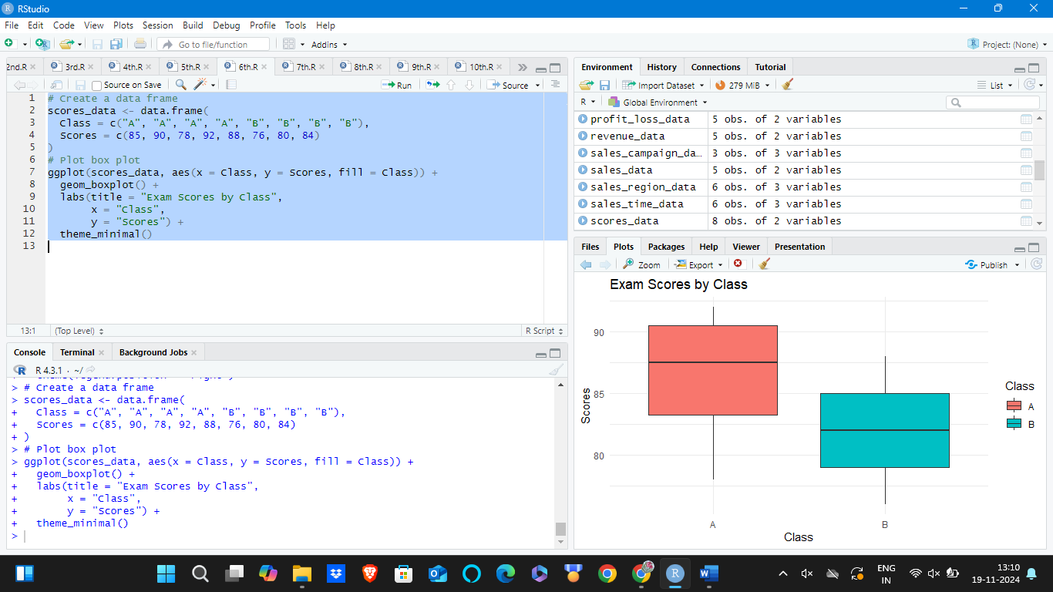

**7. Density Plot**

**Dataset: Weights of Individuals**

|  |  |
| --- | --- |
| | **Weight (kg)** | | --- | |
| |  | | --- | | 60 | |
| |  | | --- | | 65 | |
| |  | | --- | | 70 | |
| |  | | --- | | 75 | |
| |  | | --- | | 80 | |
| |  | | --- | | 85 | |
| |  | | --- | | 90 | |
| |  | | --- | | 95 | |
| |  | | --- | | 100 | |

**# Create a data frame**

**weights_data <- data.frame(**

**Weight = c(60, 65, 70, 75, 80, 85, 90, 95, 100)**

**)**

**# Plot density plot**

**ggplot(weights_data, aes(x = Weight)) +**

**geom_density(fill = "lightblue") +**

**labs(title = "Density Plot of Weights",**

**x = "Weight (kg)",**

**y = "Density") +**

**theme_minimal()**

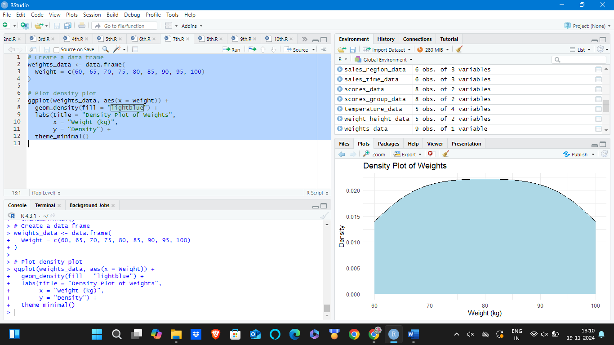

**8. Violin Plot**

**Dataset: Scores by Group**

|  |  |
| --- | --- |
| Group | Score |
| X | 80 |
| X | 85 |
| X | 78 |
| X | 92 |
| Y | 88 |
| Y | 76 |
| Y | 80 |
| Y | 84 |

**# Create a data frame**

**scores_group_data <- data.frame(**

**Group = c("X", "X", "X", "X", "Y", "Y", "Y", "Y"),**

**Score = c(80, 85, 78, 92, 88, 76, 80, 84)**

**)**

**# Plot violin plot**

**ggplot(scores_group_data, aes(x = Group, y = Score, fill = Group)) +**

**geom_violin() +**

**labs(title = "Scores by Group",**

**x = "Group",**

**y = "Score") +**

**theme_minimal()**

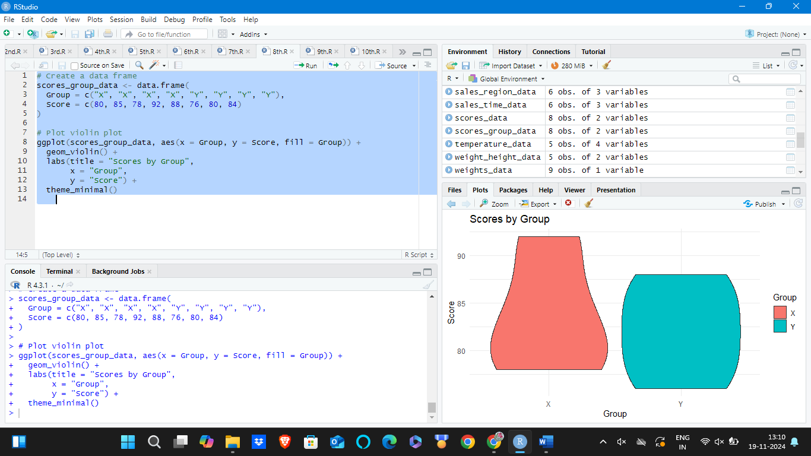

**9. Heatmap**

**Dataset: Monthly Temperatures**

|  |  |  |  |
| --- | --- | --- | --- |
| Month | City A | City B | City C |
| Jan | 5 | 10 | 15 |
| Feb | 6 | 11 | 16 |
| Mar | 7 | 12 | 17 |
| Apr | 8 | 13 | 18 |
| May | 9 | 14 | 19 |

**# Create a data frame**

**temperature_data <- data.frame(**

**Month = c("Jan", "Feb", "Mar", "Apr", "May"),**

**City_A = c(5, 6, 7, 8, 9),**

**City_B = c(10, 11, 12, 13, 14),**

**City_C = c(15, 16, 17, 18, 19)**

**)**

**# Reshape data for heatmap**

**library(reshape2)**

**melted_data <- melt(temperature_data, id.vars = "Month")**

**# Plot heatmap**

**ggplot(melted_data, aes(x = Month, y = variable, fill = value)) +**

**geom_tile() +**

**scale_fill_gradient(low = "white", high = "red") +**

**labs(title = "Monthly Temperatures",**

**x = "Month",**

**y = "City") +**

**theme_minimal()**

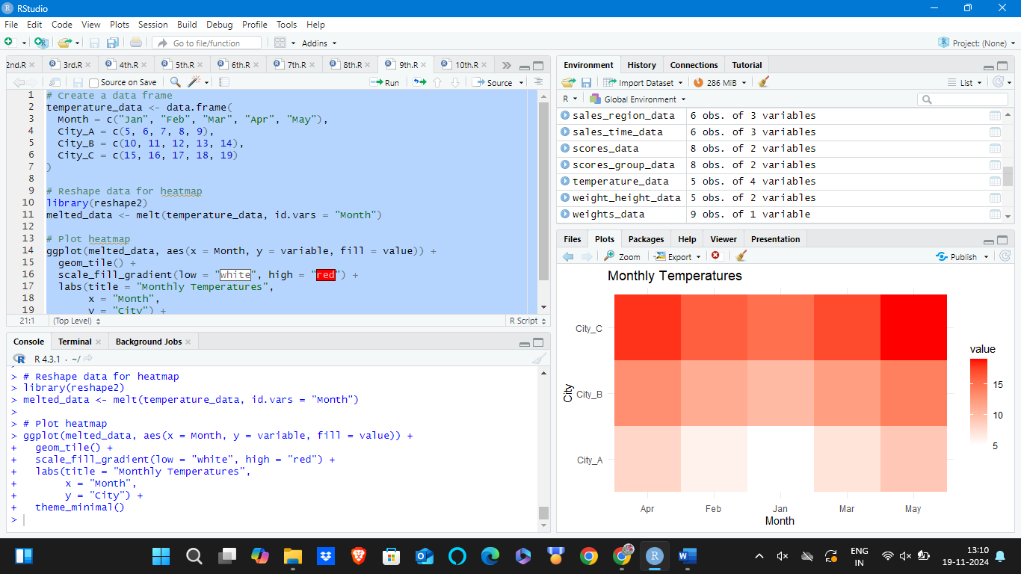

**10. Facet Plot**

**Dataset: Sales by Month and Region**

|  |  |  |
| --- | --- | --- |
| Month | Region | Sales |
| Jan | East | 200 |
| Jan | West | 150 |
| Feb | East | 220 |
| Feb | West | 170 |
| Mar | East | 210 |
| Mar | West | 160 |

**# Create a data frame**

**sales_region_data <- data.frame(**

**Month = c("Jan", "Jan", "Feb", "Feb", "Mar", "Mar"),**

**Region = c("East", "West", "East", "West", "East", "West"),**

**Sales = c(200, 150, 220, 170, 210, 160)**

**)**

**# Plot facet plot**

**ggplot(sales_region_data, aes(x = Month, y = Sales, fill = Region)) +**

**geom_bar(stat = "identity", position = "dodge") +**

**facet_wrap(~ Region) +**

**labs(title = "Sales by Month and Region",**

**x = "Month",**

**y = "Sales") +**

**theme_minimal()**

